Validating LabVIEW-RT Platforms
for Operation at High Altitudes

David S. Thomson, Ph.D.
Aeronomy Laboratory
National Oceanic and Atmospheric Administration
and
Original Code Consulting
National Instruments Alliance Member

Introduction
The NOAA Aeronomy Laboratory has developed numerous custom atmospheric chemistry instruments designed for measurements on board high-altitude research aircraft such as the NASA ER2 or WB57 as well as for the NOAA WP-3 and other lower-altitude aircraft. Historically, the data acquisition and control systems for these instruments has typically been based on PC104 computers running DOS and QuickBasic or C code. However, several factors have begun to push the lab into looking for a newer, more powerful solution. Among these factors are 1) the aging of the presently-used technology, such that software packages are no longer supported or sold and hardware is hard to replace, 2) the increasing complexity of the instruments, and 3) the trend on the aircraft towards networking instruments together. In addition, commercially available hardware has recently begun to catch up with the data acquisition needs of these instruments, such that high speed counters (80 MHz with a PXI-6602) and high-channel density A/D's (64 SE channels with a PXI-6031) are now available and can replace hardware that previously was custom built and difficult to maintain.
Several special requirements must be considered when deciding on a computer platform for such airborne instruments. In almost all cases, size, weight, and power consumption must be minimized. For many installations, vibration is a consideration, necessitating robust mechanical systems and possibly the use of solid state hard drives which, having no moving parts, are much more immune to vibration than standard hard drives. Finally, depending on the aircraft, the flight altitude, and the location in the aircraft, these instruments must be able to operate at various reduced pressures. Some aircraft locations are partially pressurized, whereas others are at ambient pressure. At the reduced pressures encountered at high altitude, one must consider at least three possible failure modes. The first of these is mechanical hard disk failure. Although most hard disks are “hermetically” sealed, in practice, they cannot be operated at altitudes much above 10,000 feet. When their internal pressure falls below a certain level, the heads no longer float above the platters, and the heads crash. Severe vibration present in some locations of certain aircraft can also cause hard disks to cease operating. The second failure is the potential for high voltages to arc. At 65,000 feet, the normal voltages used to run commercial electronics do not pose problems, so arcing is a more significant issue for other high-voltage components of the instruments. The final failure mode is overheating. When the pressure is reduced, there is less air to carry heat away from electronic components. Although this is often partially compensated for due to the lower ambient temperatures at high altitude, the lower temperature is not adequate to cool many modern electronics. (In general, though the ambient temperature can get many degrees below 0 C, the operating temperature of the instruments is usually held in the range of 10 to 25 C to prevent other problems (notably condensation upon landing) related to cold-soaking.)
In addition to addressing the above failure modes, an airborne computer platform must also have a proven reliability. Although DOS is not a real-time operating system, its simplicity and lack of disk caching have earned it a reputation of reliability and immunity to disk corruption when power is lost. Alternatively, most versions of Windows suffer from the possibility that the hard disk can become corrupt if the power is lost before the operating system (OS) shuts down. Thus a robust operating system and software environment are critical to instrument control.
Despite the potential problems inherent in Windows, it should be noted that numerous instruments have successfully been developed at NOAA using Windows-based computers. In particular, the PALMS (Particle Analysis by Laser Mass Spectrometry) instrument has been running successfully for 7 years under Windows NT and Windows 2000 using LabVIEW as the programming environment.¹
This previous success with LabVIEW prompted the Aeronomy Lab to further investigate some of National Instruments newer technologies which may be applicable to this type of instrument design. In particular, LabVIEW RT running on PXI and FieldPoint platforms is an intriguing platform with many potential advantages. The relatively new PXI-8145 controller incorporates many advantageous features. It is smaller than most PXI controllers (only 2 slots wide), uses a low-power laptop grade processor, and has two compact-flash solid-state disk slots. Putting this controller in a PXI-1002 chassis thus provides a small, light weight, low-power system on which LabVIEW-RT can be run. Since this is an embedded (headless) controller, it has the further advantage of lacking a video port. Besides the CPU, the video chip is often one of the hottest components in a PC and hence a likely failure point at low pressure. Since this controller runs LabVIEW-RT, it runs software that can easily be developed on a PC, but runs it under a robust real-time operating system. Unlike Windows, the shutdown procedure for LabVIEW-RT is to cut off its power. Hard disk corruption has not been known to be a problem for this OS.
The recently released Compact FieldPoint cFP-2020 controller provides another potential LabVIEW-RT target. This controller uses a solid state hard disk and a low-power 486-class CPU, making it a natural candidate for high-altitude applications. In addition, the new Compact FieldPoint line of products has been designed for increased robustness, including a solid backplane. The wide range of FieldPoint modules with integrated signal conditioning can accommodate many experimental needs. However, the realitvely slow speed of the FieldPoint system (typically 10's of Hz), along with the lack of 3rd-party hardware, are potential drawbacks that may make it inappropriate for some uses.

Procedure
Once the benefits of a PXI system for high-altitude instruments were recognized, it was decided that the NOAA Aeronomy Lab, in conjunction with National Instruments, would perform a series of pressure tests to determine the operating limits for various PXI and FieldPoint components. The PXI-1002 chassis comes with a standard 250W ATX power supply. In order to further optimize the system for aircraft operation, this supply was replaced with a 100W 1U-sized supply from ICP Electronics. The lower power rating of this supply more closely matched the low-power configuration anticipated for aircraft instrumentation, hence this replacement resulted in saving weight, space, and power consumption. Most importantly, however, this supply, the ACE-815C, has a 18-36V DC input, allowing it to be run off the 28V DC power common on aircraft.
It was determined that a number of hardware configurations would be tested at various pressures. In addition to the PXI-8145, which has a 266 MHz Pentium, the PXI-8174 controller with a 566 MHz Celeron would also be tested. This controller represents a compromise between increased computational power and higher electrical power consumption. Although even more powerful PIII-based controllers are available from NI, it is anticipated that they would have even lower maximum useful altitude ratings due to their higher electrical power consumption. As for the Daq hardware, due to limited resources and time, only a small but representative subset of the available PXI modules were tested. These include the PXI-6025E and PXI-6051, general-purpose multifunction cards; the PXI-6602, and 8-channel counter-timer card, the PXI-6115, a 4 channel high-speed simultaneous A/D card, the PXI-6533, a 32-bit buffered DIO board, the PXI-6071, a high-channel-density multifunction card, and the PXI-4472, an 8 channel, high resolution dynamic signal analysis board. The PXI-8145 controller with the PXI-6025E multifunction card and PXI-6602 counter/timer card are shown in Figure 1a, installed in the bell jar.
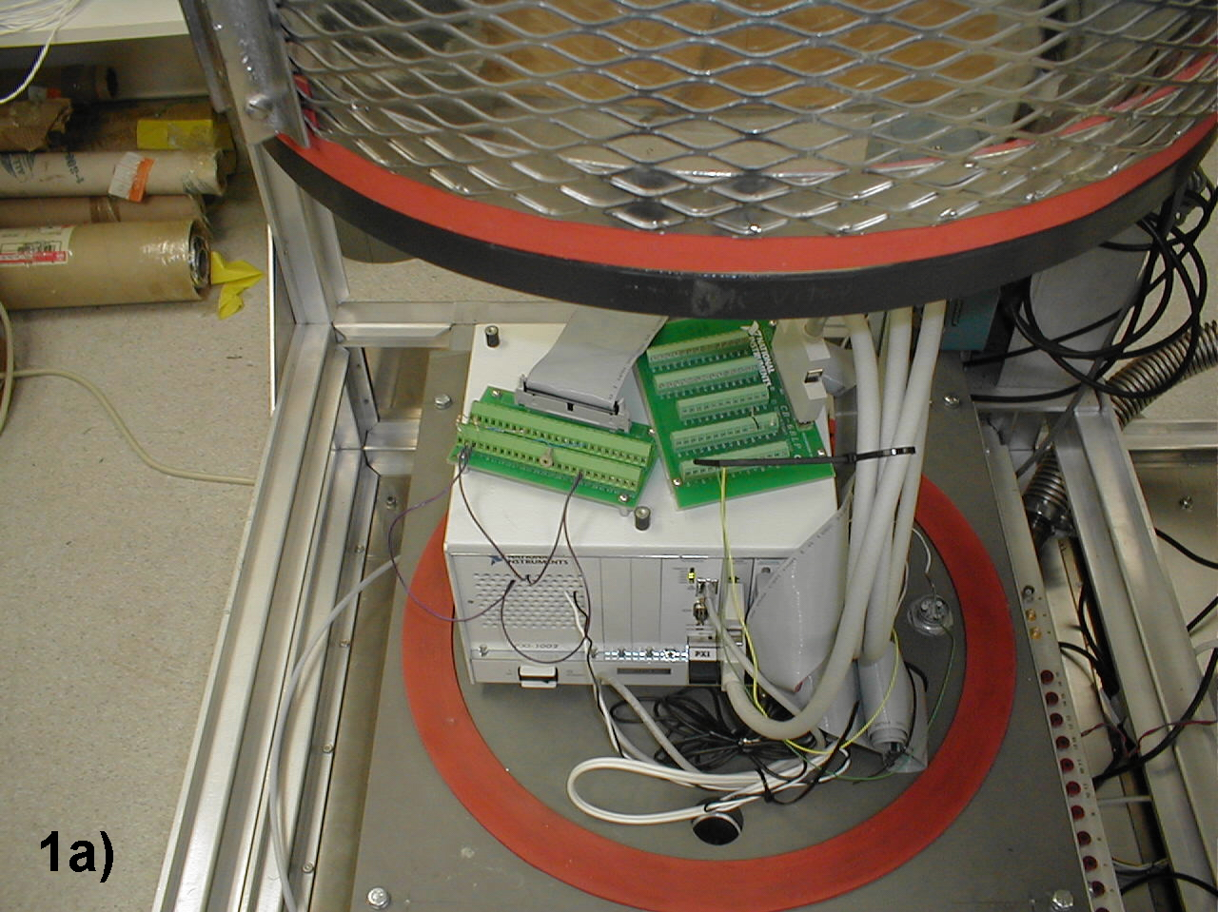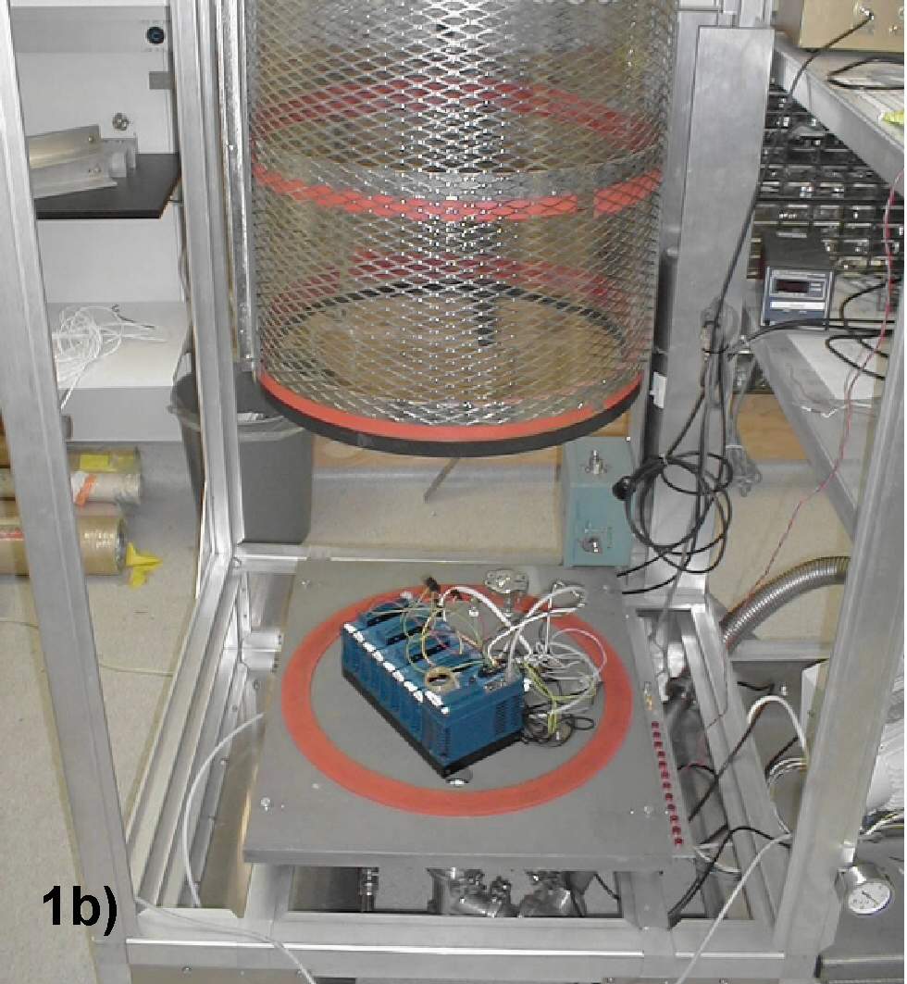
Figure 1. 1a shows the PXI-1002 chassis with the System 1 (as defined in Table 2) configuration installed. 1b shows the Compact FieldPoint setup, defined in Table 2 as System 6.

Figure 1b shows the Compact FieldPoint system ready to be tested. The cFP-2020 controller is on the right. The four modules tested in this configuration were a cFP-TC-120 thermacouple module, a cFP-DO-410 digital output module, a cFP-DI-330 digital input module, and a cFP-AI-100 analog input module. Since this system runs off of DC power, which is readily available on most aircraft, no special power supply was used and the DC power supply was located outside of the bell jar.
The test procedure was determined to be the following. For each set of hardware being tested, at least one unit would monitor and log several temperatures. This log file would act as the definitive test of whether the system operated successfully at a given pressure. In addition, each of the Daq modules being tested would be operated at a significant fraction of their capacity. Thus the A/D board measuring temperatures would be set to acquire data at a high clock rate, even though the data was only being logged once a second. The counter board and the digital I/O board would similarly be configured to clock a significant fraction of the output channels at a relatively high clock rate. This simulates a fairly demanding application, and thus tests the ability of these boards to dissipate the heat associated with high clock rates at the test pressure.
Each set of hardware would be tested at a series of pressures, as listed in Table 1. Starting at the highest pressure, the system was monitored for 1 hour at each pressure, continuing to lower pressures until the system failed. Once the system failed, the pressure was reduced to the next highest point and the system was tested for 8 hours. If the system failed that test, another 8 hour test was performed at the next highest pressure level. Following this procedure, a minimum pressure (maximum altitude) was found for each system at which the system operated successfully for at least 8 hours.

Pressure (mbar) | Altitude (ft) | Approximate typical flight ceiling for research aircraft:
400 | 20,000 | Numerous small aircraft
300 | 27,000 | P3 (NOAA, Navy)
150 | 42,000 | DC8 (NASA, others)
100 | 50,000 | Hiaper (NCAR)
55 | 65,000 | WB57 (NASA, Air Force)
45 | 70,000 | ER2 (NASA)
Table 1. Pressures and corresponding altitudes used in the test procedure.

The composition of the various systems tested is shown in Table 2, along with the resulting maximum operating altitudes. Note that the pairing of the PXI-6052, PXI-6071, and PXI-4472 with the PXI-8174 controller rather than the PXI-8145 was arbitrary with respect to the test procedure and was actually determined by the hardware availability schedule. It should also be noted that although LabVIEW RT is a significant focus of this work, the PXI-8174 controller was actually running LabVIEW under Windows 98. Although this changed some of the procedure related to monitoring its operation over the network, it should not significantly affect the results of the pressure tests. (It is possible that one operating system or the other is slightly more efficient at running similar LabVIEW code, resulting in slightly less heat dissipation. However, these tests are intended as general guidelines, and do not have the precision required to make this affect noticeable.)

Results
The maximum operating altitudes found for each system are shown in Table 2 below. In addition to the procedure above, several points should be noted. For the PXI tests, it was found that the controller was the first component to fail. Typically, the CPU would heat up significantly and the system would lock up, and later perusal of the log file showed that no more data was logged at this point. However, boards such as the 6602 or 6533 which were performing buffered output were still observed to be functioning after the CPU had failed. Furthermore, although the data acquisition program was running on the PXI controller in each test, the PXI host computer was left connected via ethernet during the tests to monitor the operation. When the controllers failed, the connection to the host also terminated. A final observation on the failures is that when the PXI controllers failed due to overheating, they had to be cooled down before a reboot would lead to resumed operation. After rebooting, however, the operation appeared to be normal and the units appeared undamaged.

Configuration | Controller | Modules | Maximum Operating Altitude
System 1 | PXI-8145 | PXI-6025E, PXI-6602 | 42,000
System 2 | PXI-8145 | PXI-6115 | 42,000
System 3 | PXI-8145 | PXI-6025E, PXI-6533 | 42,000
System 4 | PXI-8174 | PXI-6052 | 27,000
System 5 | PXI-8174 | PXI-6071, PXI-4472 | 27,000
System 6 | cFP-2020 | cFP-TC-120, cFP-DO-410, cFP-DI-330, cFP-AI-100 | 70,000
Table 2. Test system configurations and their maximum operating altitudes.

For the first five systems using the PXI controllers, one thermistor measured the bell jar air temperature, one measured the temperature of the power supply case, and a third was placed in a notch in the CPU heatsink. Also, for System 5, the air thermistor was also measured by one channel of the PXI-4472 in addition to being one of the three channels measured by the PXI-6071. It should be noted that even though the third thermister was not very well attached to the heatsink thermally, it registered surprisingly high temperatures during these tests. When System 1 failed at 50,000 feet, the CPU thermister measured over 100 C. During the successful 8 hour tests at 42,000 feet, the CPU thermister measured over 80 C. Since this thermister is poorly connected to the heatsink, the heatsink is likely hotter than the thermister, and the CPU itself is likely significantly hotter still. Thus, although the PXI-8145 systems passed the 42,000 foot test, it is anticipated that these extreme temperatures could well stress the components and lead to early failures. In general, these test are guidelines, and actual implementation of these systems in high altitude instruments must be done carefully with attention to the specific situation. For example, to implement a reliable configuration similar to System 1 in an environment equivalent to 42,000 feet or more of altitude, it would be wise to provide extra cooling to the CPU. The same components flying at 20,000 feet, however, would likely be adequately cooled in their commercial configuraiton.
Being a fairly closed system, the air in the bell jar heated up in response to the power being dissipated by the PXI system. In general, the bell jar air temperature rose to above 30 C for the PXI tests. Many airborne systems run significantly cooler than this. This lower ambient temperature could provide an additional safety overhead for a given altitude of operation, or could be used to extend the operating altitude. In addition, the small physical size of the PXI-8145 controller (and, to a lesser degree, the 3-slot wide PXI-8174) means that the processor is quite accessible, and it would not be difficult to add additional cooling to this component, which could push the usable altitude even higher.
Since the Compact FieldPoint system is designed for lower-bandwidth data acquisition, the testing program for these units did not attempt to run the modules near their highest data rates. For the System 6 test, one K-type thermocouple measured the temperature near the top of the cFP-2020 controller, one analog input monitored the 13V power supply voltage, and one of the digital outputs was set to a 1 Hz square wave and was then routed into one of the digital inputs. No failures were observed for this system at any altitude tested.
As mentioned above, a reduction in ambient temperature could be used to increase the operational altitude for these systems. To first order, the equilibrium temperature of a convectively-cooled component is expected to vary linearly with the inverse of the pressure (or the number of air molecules present to carry away heat). In reality, as the pressure is reduced, the equilibrium temperature likely climbs at a slower rate than linearly with respect to inversse pressure (1/P), due to eddies and other 2nd order effects. Since data for bell jar air temperature and CPU and power supply temperatures were available at a number of pressures, it was easy to verify this assumption. The data for the PXI-8145 system is shown in Figure 2. As can be seen, for both the CPU and the power supply, the rise in temperature with decreasing pressure has a dependence on 1/P that is less than linear. Thus, it should be safe to estimate additional operating altitude based on a 1/P dependence on the proposed reduction in ambient temperature.

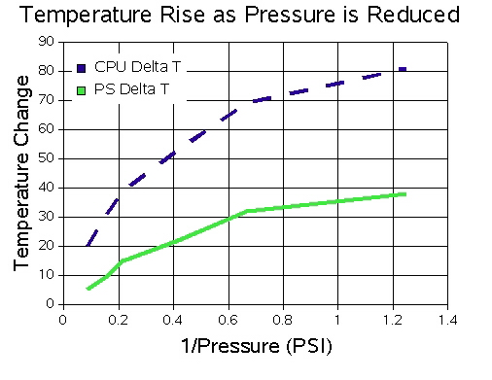Figure 2. Rise in CPU and Power Supply Temperature as the pressure is reduced, showing a less-than-linear dependence in both cases. Temperature change is in degrees C and pressure is in units of 1/PSI.

Conclusions
As can be seen from the results in Table 2, off-the-shelf LabVIEW RT systems have considerable potential for deployment at reduced pressures. These tests have indicated that a PXI-8145 based system can likely be used at altitudes of about 42,000 feet, whereas a PXI-8174 based system is operational to about an altitude of 27,000 feet. In addition, the newly-released cFP-2020 based system was successfully tested up to 70,000 feet. It should be remembered that these tests are intended as guidelines only. They do not certify or guarantee the operation of any of these products at any pressures. In addition, a limited subset of modules and plug-in cards were tested, and not all the plug-in cards used were tested to the same altitude. However, these results should allow instrument developers to approach the design of high-altitude instrument data acquisition and control systems with some confidence in the likelyhood of these products working in particular conditions. These tests indicate that numerous airborne instruments can be developed using reliable, commercial off-the shelf components.

References
1) D.S. Thomson, M.E. Schein, and D.M. Murphy, “Particle Analysis by Laser Mass Spectrometry WB-57F Instrument Overview”, Aerosol Science and Technology, 33, 153 (2000).

